**Choose ‘Add features to an existing…’**

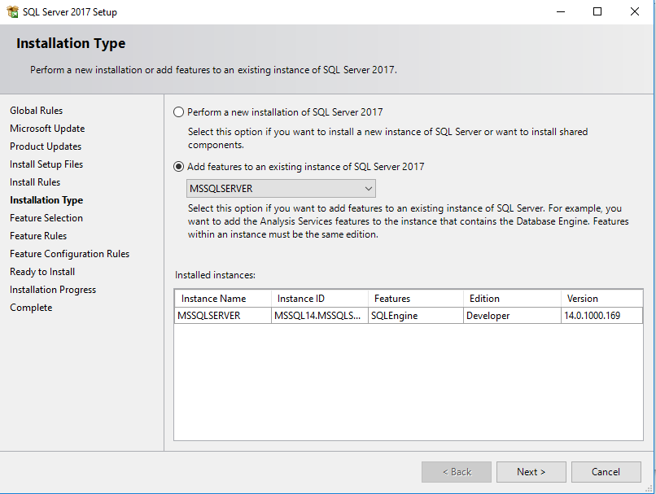

**Select ‘Analysis Services’ to install**

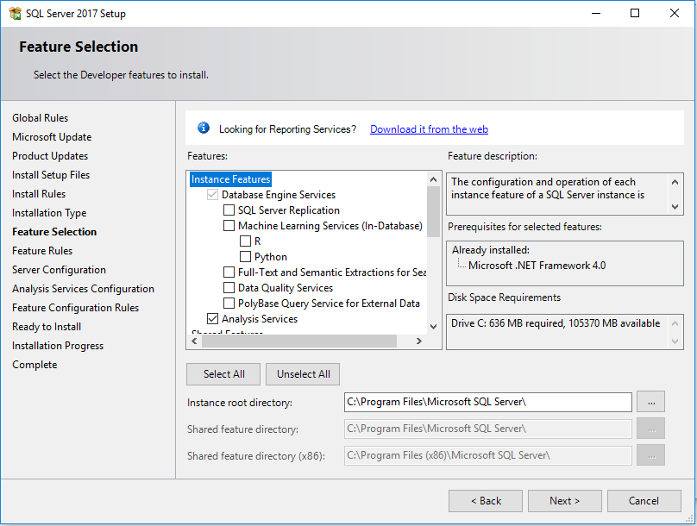

**Choose ‘Multidimensional and Data Mining Mode’ and also Add Current User**

